***Every step of this assignment is critical for classroom safety. Failure to complete these instructions precisely will result in a failing grade. Do not damage the 10th grader’s RPi project!***

1. Untie all cables under the desk and clear as much space as you need. Pull all cables except mouse and keyboard up through the desk hole and drape over back of desk.
2. Remove clamp hardware and replace with through-hole clamp used for clamping the post through the desk hole.
3. Loosely clamp the post through the center hole (do not do this step with any monitors or computers attached!). The cable notches on the clamp must be in the rear of the desk.
4. Drape the cables over the front of the desk for easy handling

1. Make each end of each cable that runs to the PC or Monitor long to run from the desk hole to barely touching the floor.
   1. Do not run mouse and keyboard through this hole
   2. Ethernet may not be long enough. If so, pull out *most* of the slack so it is as long as it comfortably can be.
   3. If the DVI/DP cable is not long enough to follow these instructions, do not run it through the clamp cable slot (some display cables are very short)
2. The Raspberry Pi Power and micro-side of the HDMI should be the same length, with enough slack to pull the Raspberry Pi to the edge of the top portion of the desk. 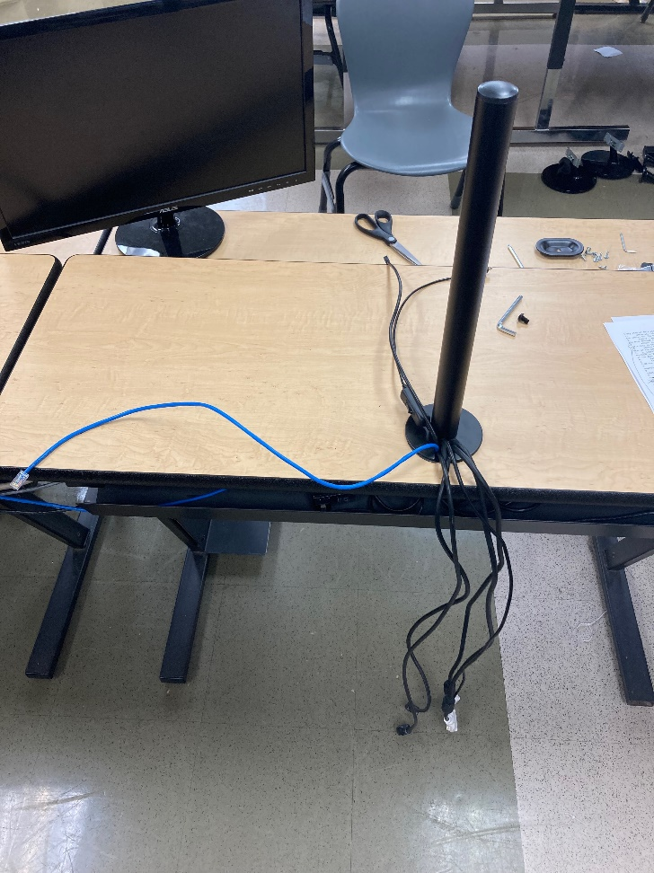
3. Temporarily Velcro loop the cables to the post to avoid losing the slack as you clamp down the post.

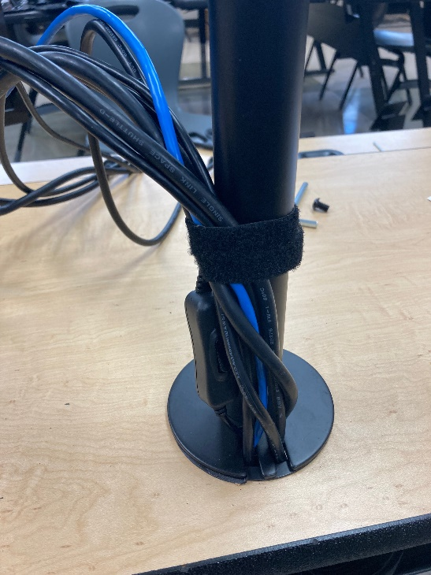

1. **Center** the upper and lower clamp pieces over the hole and tighten until the post cannot be moved or twisted by hand.

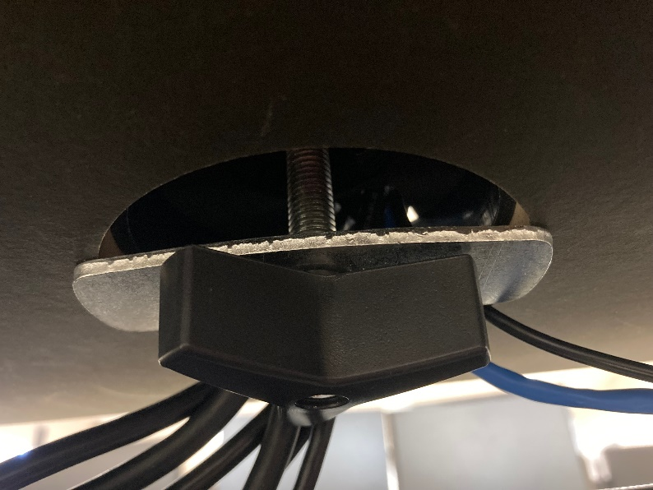

1. Place the power strip in the cable tray neatly so that it cannot fall out.
2. Pull out all of the excess cable under the desk into a big loop, and zip tie at the top of the loop to take the slack out of the cables.
3. Fold the loop in half and zip tie the center. Tuck the cable loop into the cable tray neatly. 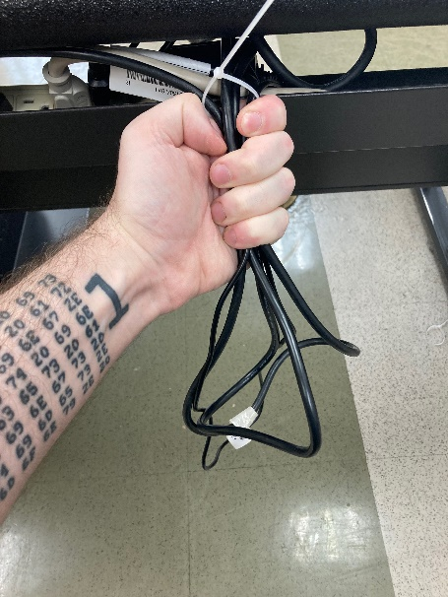A picture containing person, kitchen appliance

   Description automatically generated
4. Attach the rectangular cable clips to the horizontal arms and the round cable clip to the post.
5. Attach the horizontal arms to the post with the clamp adjustment bolt in the rear of the post. The horizontal arms and their clamp must be parallel with the edge of the desk.

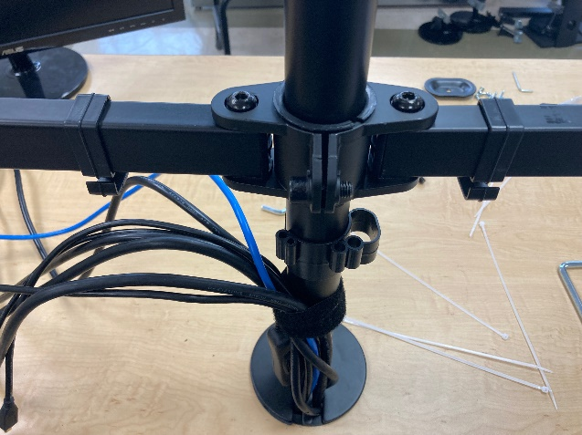

1. Attach the PC to the left arm, and the Monitor on the right arm.
2. Tighten the vertical hinge where each screen attaches to the arms so that it does not droop, and the screen is perpendicular to the desk.
3. Adjust the height bolt where the screens are attached to the arms so that the visible area of each screen is as level to each other as possible.
4. Adjust the height of the horizontal arm clamp so that a Raspberry Pi stood on its long edge can just barely fit under the PC, then tighten the clamp again. The clamp should be just tight enough the clamp cannot be twisted by hand.
5. Fold the arms back so that the screen edges are no more than one inch apart and one inch away from the post, folded inward at a very slight “V” shape.
6. The mouse and keyboard cables must run under the desk into the mouse/keyboard cubby
7. Un-Velcro the cables and run the cables through the circular cable clip, and the two appropriate square cable clips on the arms holding the PC or screen they plug into.
8. Put the three Allan wrenches in the circular clip on post.
9. Put all extra screws and hardware in a zippy bag and tape to the back of the post.
10. Put all extra monitor stands and large hardware on the table in the back of the class.
11. Put the Raspberry Pi back neatly.
12. Have your instructor sign this assignment

